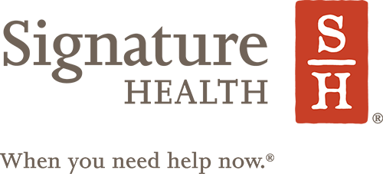

Please Fax the completed form to 440-974-8816
Please DO NOT send medical records to this fax number

New Client Registration Form (Please Print)
Patient Name: |  | Birth Date: |  | Social Security #:
Home Phone:  OK to leave a message: ❏ Y ❏ N |  | Mobile Phone:  OK to leave a message: ❏ Y ❏ N |  | Gender: ❏ Male ❏ Female
Address:
City: |  | State: |  | Zip Code:
Email Address: |  |  |  | Ok to send emails? ❏ Yes ❏ No
Parent/Legal Guardian (If Applicable): |  |  |  | Phone Number:
Emergency Contact: |  | Phone Number: |  | Relationship to Client:
Reason for Referral |  | Referral Source: |  | Patient Discharge Date:
Signature Health Location to receive services from:
❏ Ashtabula ❏ Beachwood ❏ Lakewood ❏ Maple Heights ❏ Painesville ❏ Willoughby
Health Insurance Plan(s) ❏Medicare ❏Medicaid ❏Other:______________________________
Insurance Name:____________________________
Billing/MMIS#:______________________________ ID#:_____________________________
US Citizen: ❏ Yes ❏ No |  | Active Military : ❏ Yes ❏ No  Veteran: ❏ Yes ❏ No |  | Primary Language:  Translator Needed: ❏ Yes ❏ No
Race: ❏ American Indian/Alaska Native ❏ Black/African American ❏ White/Caucasian ❏ Hispanic
❏ Native Hawaiian/Pacific Islander ❏ Multiracial/Multicultural ❏ Asian ❏ Declined/Unknown
Ethnicity: ❏Hispanic ❏Not Hispanic ❏Unknown ❏Declined
Any difficulty ❏ hearing, ❏ reading or ❏ writing? If checked, please explain
Any special communication needs or physical accommodations needed for the appointment? ❏ Yes ❏ No
If yes, please explain

Gender at Birth: ❏ Male ❏ Female
Gender Identity: ❏ Male ❏ Female ❏ Transgender Female to Male ❏ Transgender Male to Female ❏ Other ❏ Chose not to disclose
Sexual Orientation:
❏ Lesbian/Gay ❏ Straight ❏ Bisexual ❏ Something Else ❏ Don’t Know ❏ Chose not to disclose
Monthly Income Amount: | Source of Income: |  | Household Size:
Referring Facility Information
Facility Name: | Contact Name: | Phone Number:
Address:
City: | State: | Zip Code:

